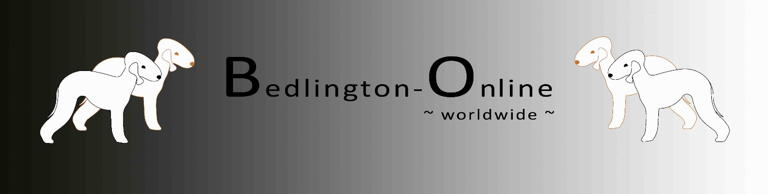

Application for admission of a litter
on the Website „Bedlington-Online.com“

Kennel: | Text
Day of Birth: | Date | Number of puppies: | M/F | Colors: |  | ☐ blue – M/F  ☐ liver – M/F  ☐ sandy – M/F  ☐ blue & tan – M/F  ☐ liver & tan – M/F  ☐ sandy & tan – M/F
Father: | Text |  |  | DNA: |  | Choose DNA | Farbe: Choose Color
Mother: | Text |  |  | DNA: |  | Choose DNA | Farbe: Choose Color
Breeder: | Text |  |  |  |  |  |  |  | (Name, City, Country)
Phone: | Telefonno. |  | E-Mail: |  | Text
Homepage: | Text |  | Facebook: |  | Text |  |  | (Name)

Please send this form together with following documents by E-Mail (info@bedlington-online.com):

- Pedigree of the Parents
- Pictures (if you want)

☐ Publication in the "Mediation" section is desired for:

☐ blue – M/F
☐ liver – M/F
☐ sandy – M/F
☐ blue & tan – M/F
☐ liver & tan – M/F
☐ sandy & tan – M/F

Changes can be made anytime.

With my signature I confirm that all of the above information is correct. I also give my consent that the aforementioned information may be published on the website www.bedlington-online.com (administered by Nina Bläser, Bochum). As soon as I no longer wish to be published, I will inform Miss Bläser about it.

City | Date
City | Date |  | Signature of the Owner

